

Manage IQ

Functional Specification Document

June 4, 2018

Pranay Udapure

Email: pranay.udapure@click2cloud.net

Document Version – V 1.0

Version History

|  |  |  |  |
| --- | --- | --- | --- |
| Version | Date | Name | Description of Change |
| 1.0 | 06/04/2018 | Pranay Udapure | Manage IQ – Interface Draft |
|  |  |  |  |
|  |  |  |  |
|  |  |  |  |
|  |  |  |  |

Reviewers

|  |  |  |  |
| --- | --- | --- | --- |
| Name | Version Approved | Role | Date |
| Sapan Vaswani | 1.0 | PM | 06/04/2018 |
|  |  |  |  |
|  |  |  |  |
|  |  |  |  |
|  |  |  |  |

Table of Contents

Introduction 2

Objectives 2

Scope 2

Assumptions and Constraints 3

Assumptions 3

Constraints 4

References 4

Architecture Overview 4

Prerequisites 5

System Description 5

Software 5

CODE 6

File Names and Structure 6

Disclaimer 7

Appendix A: Glossary 7

Appendix B: Document Change History and Sign-off 7

Point of Contact 7

# Introduction

## Objectives

The objective of this document is to describe technical and functional specification on Manage IQ - Telephonica deliverable SDK and interface. This document covers scope of Manage IQ - Telephonica and detailed on different parameters supported by interfaces. The Manage IQ - Telephonica will coverers the implementation of interfaces for Elastic Cloud Server(ECS), Elastic Volume Service(EVS), and Identity and Access Management(IAM)

## Scope

ManageIQ is a manager of managers and as such it needs to connect to other management systems to function. These other management systems are called providers in ManageIQ parlance. ManageIQ will connect to the providers via their API.

For each configured provider, ManageIQ will continuously discover inventory. The type of inventory depends on the provider, for example in the case of VMware vSphere it will be virtual machines, hypervisors, and other relevant elements.

## Interfaces

|  |  |
| --- | --- |
| **#** | **Interfaces** |
| **Elastic Cloud Server** | |
| 1 | Show Floating IP |
| 2 | Starting server |
| 3 | Restating server |
| 4 | Stopping ECSs in Batches |
| **Identity and Access Management** | |
| 5 | Show project details |
| **Elastic Volume Service** | |
| 6 | List volumes details |
| 7 | List Availability Zones |
| 8 | Querying task status |

## 

## Assumptions and Constraints

### Assumptions

1. The estimate includes efforts required for developing and testing Ruby SDK for Telefonica Cloud, to be used in ManageIQ.
2. We assume that, the Telefonica APIs are already available with documentation.
3. We are considering the Native APIs for Ruby SDK.
4. We assume that, all Native APIs which are required for ManageIQ works for the Telefonica Cloud.
5. We assume that, the Huawei team will help in converting English language keys and content to other supporting languages.
6. The technical platform which we will be using is FOG - OpenStack Ruby SDK.
7. Change in any functional requirement documented below shall be treated as CR (Change Request).
8. This document to be freeze and sign-off before implementation start.
9. All interfaces which need to integrate, are finalized by Huawei Team under SOW.
10. All interfaces are targeted for Linux systems only.
11. ManageIQ, targets running interfaces for English language only. Other languages such as Chinese is not considered.
12. Any update within REST API or SDK for ruby should be informed to Click2Cloud Team. Click2Cloud will do required analysis and will identify the impact. If the impact is significant, then it will be communicated to stakeholders for further decision.
13. All the supporting document will be provided in English language only.

### Constraints

1. During development phase if we found that any Native API is not working as expected, it may take some efforts to analyse the issue by comparing it with cloud API.

## References

* https://github.com/fog/fog-openstack
* <https://github.com/ManageIQ/manageiq-providers-openstack>
* <https://support.telefonicaopencloud.com/en-us/api_list/index.html>

## Architecture Overview

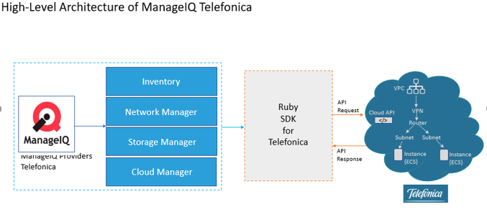

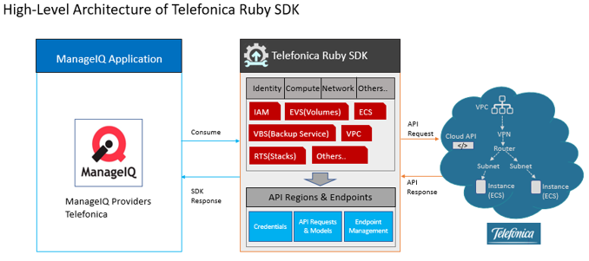

# Prerequisites

## System Description

* Supported Operating Systems:
  + Red Hat Enterprise Linux 6 64-bit
  + Red Hat Enterprise Linux 7 64-bit
  + CentOS 6 64-bit
  + CentOS 7 64-bit
  + Ubuntu 12.04 LTS 64-bit
  + Ubuntu 14.04 LTS 64-bit
  + Windows 10
* 2 GB RAM minimum (4+ GB RAM recommended)
* 20 GB hard disk
* 64-bit support required (kernel and runtime)

## Software

* Ruby Mine
* Docker
* OpenStack FOG-SDK

# CODE

## File Names and Structure

1. Project File Structure

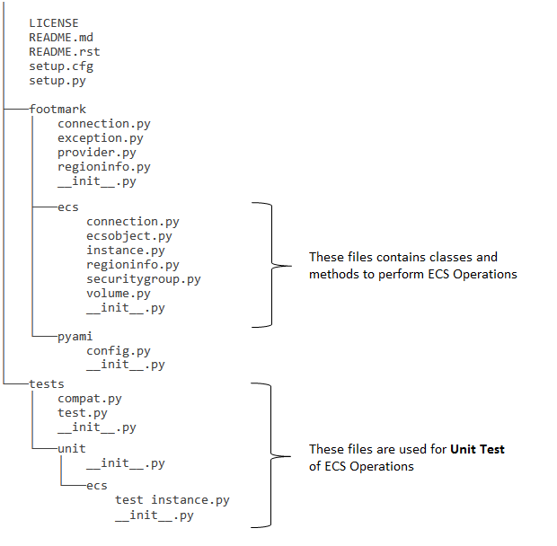

# Disclaimer

This **DRAFT** Specification is being forwarded to you strictly for informational purposes and sign-off requirement before development starts. The specification is "AS IS," "WITH ALL FAULTS" and Click2Cloud makes no warranties, and disclaims all warranties, express, implied, or statutory related to the specifications. THE CORPORATIONS ARE NOT LIABLE FOR ANY INCOMPLETENESS OR INACCURACIES. THE CORPORATIONS ARE NOT LIABLE FOR ANY CONSEQUENTIAL, INCIDENTAL, OR INDIRECT DAMAGES RELATING TO THE SPECIFICATIONS OR THEIR USE.

# Appendix A: Glossary

|  |  |  |
| --- | --- | --- |
| No. | Initial Name | Description |
| 1 | CR | Change Request |
| 2 | FSD | Functional Specification Document |
| 3 | ECS | Elastic Compute Server |
| 4 | EVS | Elastic Volume Service |
| 5 | IAM | Identity and Access Management |

# Appendix B: Document Change History and Sign-off

|  |  |  |  |
| --- | --- | --- | --- |
| Version No. | Date | Name | Sign-Off by |
|  |  |  |  |
|  |  |  |  |
|  |  |  |  |
|  |  |  |  |

# Point of Contact

|  |  |  |
| --- | --- | --- |
| Name | Designation | Email |
| Sapan Vaswani | Project Manager | [sapan.vaswani@click2cloud.net](mailto:sapan.vaswani@click2cloud.net) |
| Pranay Udapure | Sr. Lead Software Design Engineer | pranay.udapure@click2cloud.net |
|  |  |  |